

# LAB – FILE

**Graphics and Animation Tools - Lab**

**CSGG 4101**

Name – Rishank Gupta

Roll No. – R100217062

Sap id – 500062486

Course – B. Tech CSE-OSS

Batch – 2

*Under the guidance of…*

Dr.Durgansh Sharma

Associate professor

Department of Cybernetics

School of computer Science (Socs)

**Experiment- 8**

**Aim: - Design of 3D Car using Blender.**

**Steps for designing the Car**

**Step-1:** Open Blender

**Step-2:** Create a blank file and delete the default cube.

**Step-3:** To design a car from a blueprint, add the blueprints as reference images. Make sure the blueprints are of same dimensions and should be added at one place without moving them. Lock their positions.

**Step-4:** First I start from the top by adding a plane. Scale it. Switch to edit mode (Tab). Add loop cuts (add that much is required).

**Step-5:** Now start arranging the vertices according to the car’s top view. Use sub surf modifier. After it is aligned according to the top view, align them9 according to the left, right and back view respectively.

**Step-6:** To create the body for the car, extrude the vertices along Z-axis. And similarly adjust it according to the car (To match the length, breadth, height, thickness of car)

**Step-7:** Add more planes to crate the door for the car, and adjust it to fit with car.

**Step-8:** Now as the body of the car is ready, now add a circle-extrude it-give it a smooth shade. Add a rim design of choice and add it to the wheels. Now add the wheels to the car. Multiple wheels can be created using shortcut (shift+D).

**Step-9:** Now add exhausts to the car by adding two cylinders.

**Step-10:** Add rear spoiler to the car.

**Step-11:** Now to colour, add image texture to car under shading-new-base colour-image texture.

**OUTPUT SCREEN:**

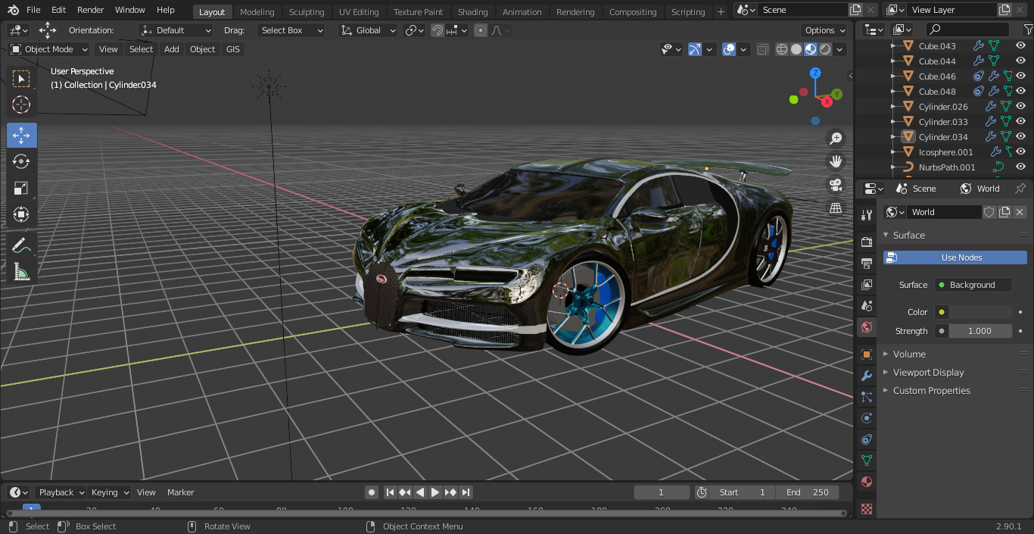

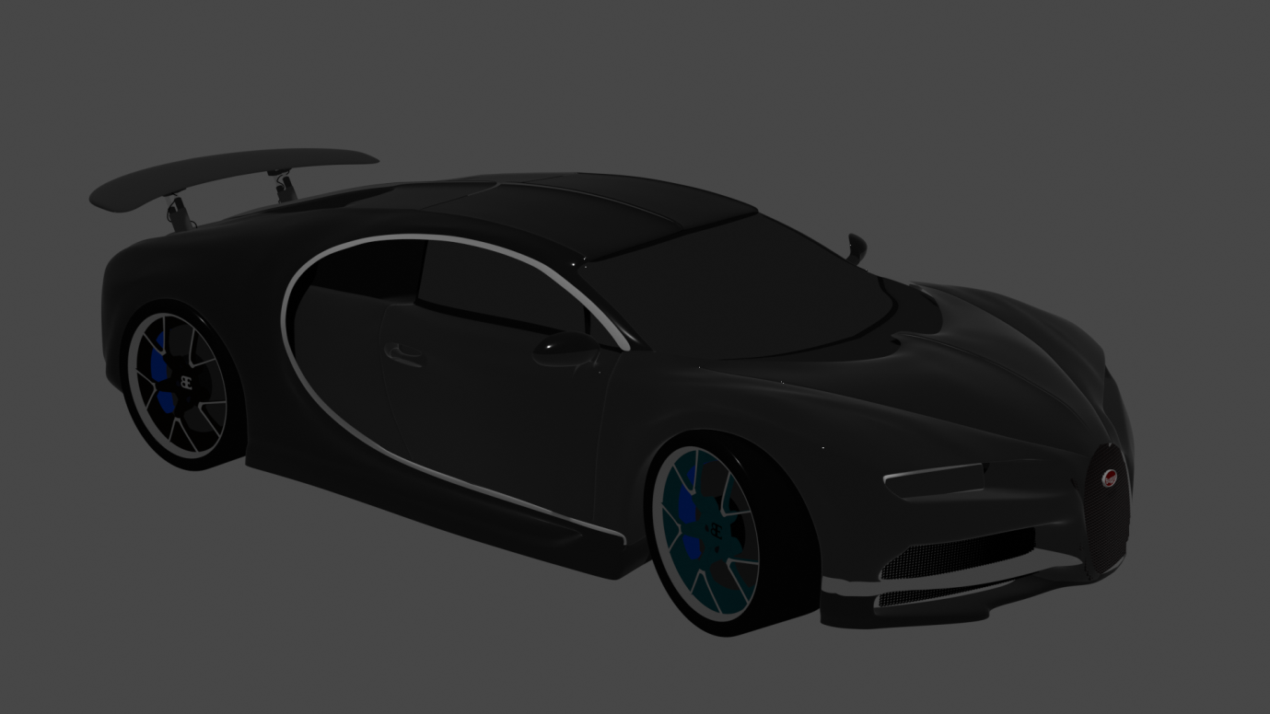

**Link:** [**https://drive.google.com/drive/folders/1mlnAw-rHKbd7fF6eR7VsllYHBn64olW6?usp=sharing**](https://drive.google.com/drive/folders/1mlnAw-rHKbd7fF6eR7VsllYHBn64olW6?usp=sharing)